**Index Number – 210098R**

**Name – De Silva APC**

**Chart –**

**Terminal outputs –**

**Discussion –**

By repeated execution the time varies for each length but the above plot is done by the random values it produced for the first execution for each array length without retrying and taking a biased result. So it turns out that almost all the time the recursive algorithm is faster than the iterative implementation when it comes to quick sort algorithm. But its noticeable that the margin is not a huge one anyway.

Probably this is happening because of the fact that recursive algorithm has the advantage of the call stack to reduce the overhead of maintaining an explicit stack. But with much larger arrays, iterative option should be faster. So I increased the scale and redid the process and it confirmed that is what exactly happens here.

**

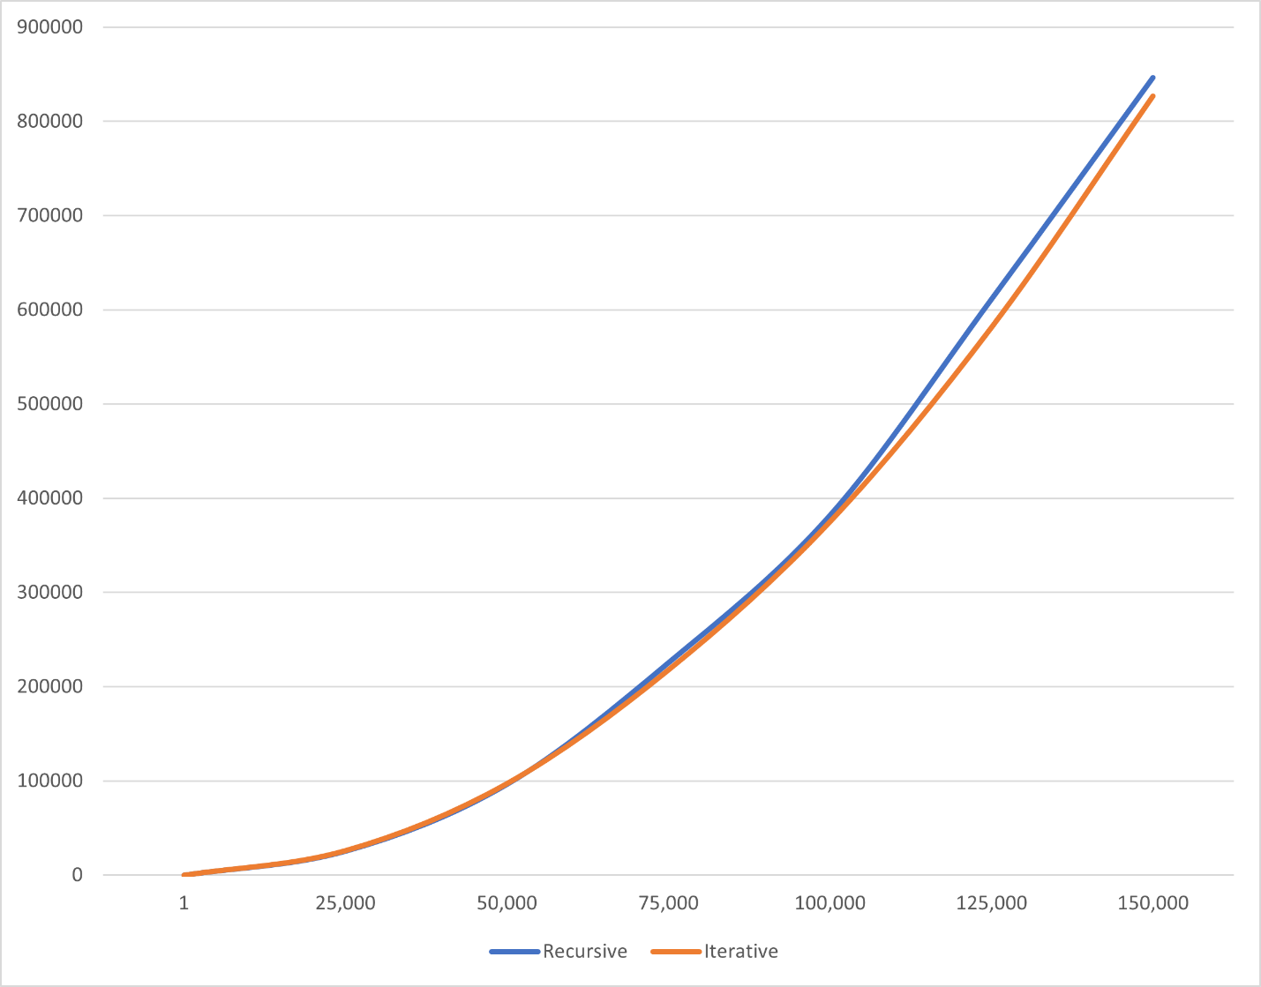

Q2 – Console output when the input is 10.

